ADVANCED SOFTWARE SERVICES, INC
FUNCTION KEYS

The following describes the standard function keys:

BRWS = The browser is a list of the file. This is functionally equivalent
to the find option of our standard package.

VIEW = View provides the ability to ADD, CHANGE, DELETE and UPDATE
an individual record.

SORT BY = The selections at the bottom of the browser which will sort the list in alphabetic order.

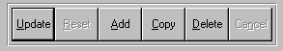

Update = Updating the current record.
Reset = Reset the current record.
Add = Add a record.
Copy = This will copy the existing record.
Delete = Delete the current record displayed on the screen.
Cancel = Canceling the information that was entered.
Save = Save the record.


 |  |  |  |  |  |  |  |  |  |  |  |  |  |  |  |  | First – Takes you to the first record
 |  |  |  |  |  |  |  |  |  |  |  |  |  |  |  |  | Prev – Takes you back one record at a time
 |  |  |  |  |  |  |  |  |  |  |  |  |  |  |  |  | Next – Moves forward one record
 | First |  |  |  | Prev |  |  | Next |  |  | Last |  |  |  |  |  | Last – Last current record
 |  |  |  |  |  |  |  |  |  |  |  |  |  |  |  |  | F2 – Search for a record
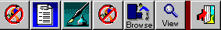 |  |  |  |  |  |  |  |  |  |  |  |  |  |  |  |  | F3 – List a record
 |  |  |  |  |  |  |  |  |  |  |  |  |  |  |  |  | F4 – Add notes to a record
 |  |  |  |  |  |  |  |  |  |  |  |  |  |  |  |  | F5 – Misc. fields
F2 |  | F3 | F4 |  |  | F5 |  |  | F6 |  |  | F7 |  |  | F12 |  | F6 – Brows the records
 |  |  |  |  |  |  |  |  |  |  |  |  |  |  |  |  | F7– View the records
 |  |  |  |  |  |  |  |  |  |  |  |  |  |  |  |  | F12 – Exit the screen

This effectively replaces the find feature of our legacy Foldware and Corrware products.
ADVANCED SOFTWARE SERVICES, INC
MAIN MENU
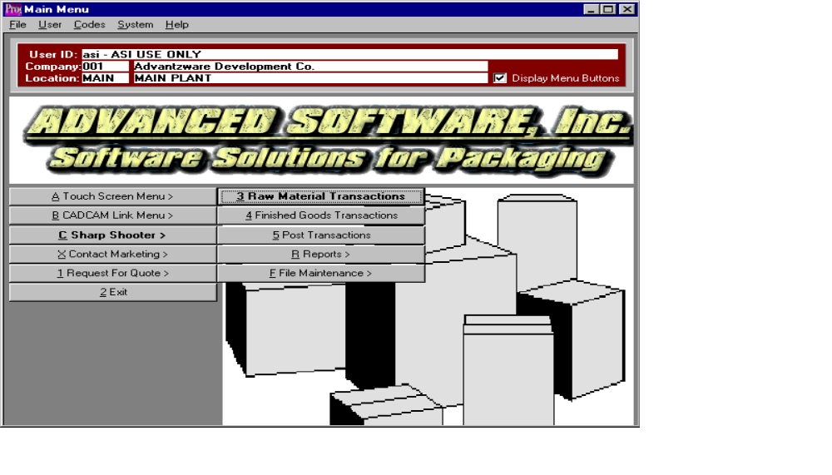

Sharp Shooter Bar Code Inventory Main Menu

Sharp Shooter requires Zebra Technologies Bar One software to produce bar code labels and load tags. It is also recommended to purchase touch sensitive computer workstations but it is not required. The sharp shooter module, in conjunction with Advantzware, will control raw materials and finished goods inventory by company, warehouse, bin location and tag number. To manage inventory by bar codes will require a unique item number for each finished good and raw material purchased or produced and a unique load tag number for each pallet load of material. The shipping, receiving and warehouse departments will need a computer, a touch screen workstation, radio frequency scanner and bar code printer as well as the Top Gun batch collection device.

Bar coding require unique real raw material item numbers, hence the job creation program will create unique material item number by utilizing the finished goods item number truncated to ten characters. If requested, combining the board code with the job number could create the item number. Once the purchase order is created, a load tag with bar code will be generated for each pallet received during the receiving process for purchased goods or from production for finished goods. The load tag will show the purchase order number, item number, job number, unit count and a bar code load tag number created by combining the purchase order number, line number, unit number and unit count for each pallet received. When raw materials are received, the receiving clerk will create load tags for the number of incoming pallets, which will simultaneously create raw materials receipts. Once the load tags are created, they will be attached to each unit. Alternatively, a vendor supplied load tag may be scanned, which will create the warehouse receipt. The receipts posting program will be used to update the inventory levels.

Raw material issues of materials to jobs will scan the load tag number, which will import the item number, tag number; job number and unit count to the data entry screen for verification. The same inventory posting logic will update the inventory files. Likewise adjustments to inventory levels for either raw materials or finished goods will require pressing the adjustment button, followed by scanning the tag numbers, then posting the transactions.

Finished goods buttons are utilized for receipts, transfer, physical counting and shipments via the bill of lading module to better facilitate the scanning of bar coded tag number with radio frequency scanners. Current Advantzware logic in order processing provides for creating load tags via Zebra Technologies Bar Code software. This logic will be replaced with creating load tags from the job file or via purchase order receipts. Once bills of lading have been created, the load tags are scanned to update the bill of lading shipment tag numbers, counts, warehouse and bin locations. For physical counting, the Top Gun batch data collection device will be utilized to scan the warehouse, bin location and tag number. Once the data has been collected off-line, the information must be updated to the database, then posted. The posting button logic will be used to update the inventory files.

ADVANCED SOFTWARE SERVICES, INC
RM - WAREHOUSE TRANSACTIONS SCREEN


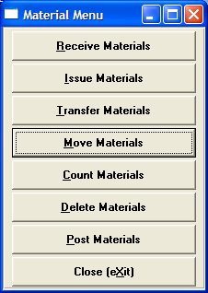

Raw Materials Warehouse Transaction Selection

Load tags may be created from purchasing or directly from the raw material file by pressing the appropriate button. When raw materials are received, the receiving clerk will create load tags for the number of incoming pallets or rolls by pressing the PO load tag button. Each tag created will simultaneously create raw materials receipts in the Enter/Edit Receipts file. Once the load tags are created, they will be attached to each pallet or roll. The load tag will show the purchase order number, raw material item number, job number, unit count, weight and a bar code load tag number, which is created by combining the purchase order number, line number, unit number and unit count for each pallet or roll received. Please note, the roll tag or pallet tag may be very simply modified to add additional fields such as width, lenth, vendor, etc. Alternatively, a vendor supplied load tag may be scanned, which will create the warehouse receipt. Receipts for materials without bar coded tags may be added via the Enter/Modify Receipts button. The Post button will update the inventory levels in the Advantzware database.

The Scan Issues button is used to issue materials to jobs by scanning the load tag number, which will import the item number, tag number, job number and unit count to the Enter/Modify Issues button for verification. The Post button will update the inventory levels in the Advantzware database.

The Scan Adjustments button is used to adjust inventory levels raw materials. Once the tag number is scanned, the quantity may be adjusted, and then the transaction should be posted to update the inventory. In addition, a new bar coded load tag should be created to reflect the new unit count.

For physical counting, the Top Gun batch data collection device will be utilized to scan the warehouse, bin location and each tag number. Once the data has been collected off-line, the information must be uploaded to the Advantzware database, then posted. The posting button logic will be used to update the inventory files.

ADVANCED SOFTWARE SERVICES, INC
RM - LOAD TAG Via PURCHASE ORDERS

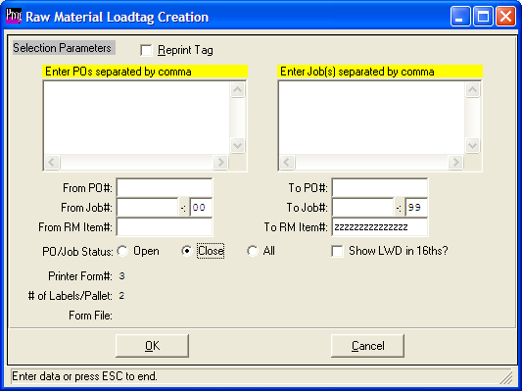

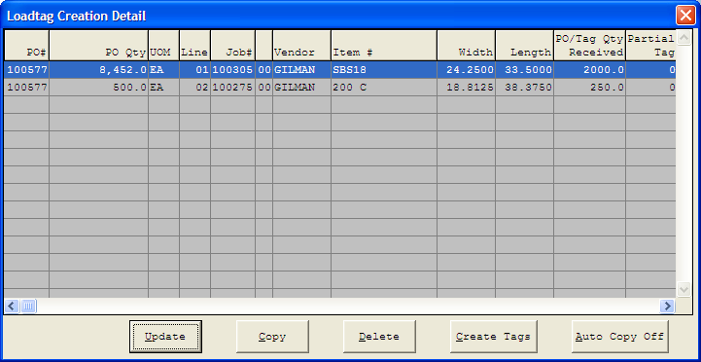

Raw Materials Load Tags SelectioN via Purchase Order

Load tags may be created from purchasing when raw materials are received. The receiving clerk will create load tags for the number of incoming pallets by pressing the PO load tag creation button on the Sharp Shooter main menu. Each tag created can simultaneously create raw materials receipts in the Advantware Enter/Edit Receipts file. The top of the screen allows entry of open purchase orders, whereas the worksheet at the bottom is a worksheet area for creating load tags for each item on the purchase order.

To create a load tag, select any item from the list of purchase orders by entering the purchase order number or by pressing the F1 key to search for a purchase order. Once the purchase order number is entered, the items are moved to the worksheet area, so that the the number of tags, quantity per roll or pallet and partial pallet quantity must be entered. For roll stock material, the program will prompt for the count, which is the quantity express by the consumption unit of measure. The roll stock unit of measure options are MSF, LB, TON and LF, which represent per thousand feet, pound, ton and lineal feet respectively. For sheets, the number of sheets per pallet are entered along with any partial pallet and the number of pallets received are entered. Once the number of load tags and unit counts have been defined, the LOAD TAGS button is pressed to print the load tags. Each tag created will simultaneously create raw materials receipts in the Enter/Edit Receipts file.

Once the load tags are printed, they will be attached to each pallet. The load tag will show the purchase order number, item number, job number, unit count and a bar code load tag number, which is created by combining the purchase order number, line number, unit number and unit count for each pallet received. Alternatively, a vendor supplied load tag may be scanned, which will create the warehouse receipt. Receipts for materials without bar coded tags may be added via the Enter/Modify Receipts button.

Inventory Load Tags SelectioN for stock items

Load tags may be created directly from raw materials for any material. This is useful for lost tag numbers and stocked material received prior to the installing the sharp shooter module. Each tag created will not create raw materials receipts in the Enter/Edit Receipts file. The top of the screen lists all the real materials in the materials file, whereas the bottom of the screen is a worksheet area for creating load tags for one or more items.

ADVANCED SOFTWARE SERVICES, INC
RM - ENTER/MODIFY WAREHOUSE TRANSACTIONS RECEIPTS
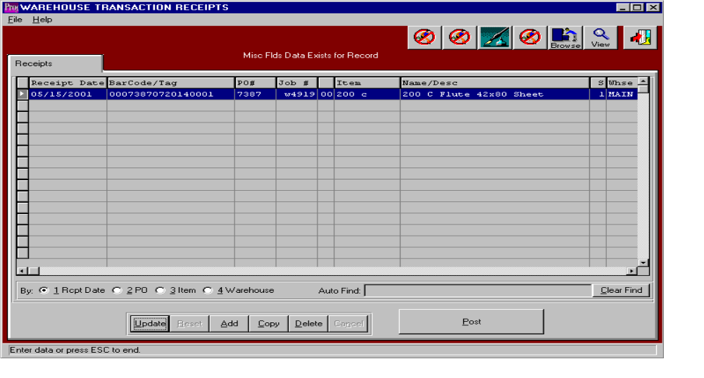

Raw Materials Enter / Modify Receipts

The PO Load Tags button is pressed to create and print bar coded load tags. Each tag printed will simultaneously create raw materials receipts in the Enter/Edit Receipts file. In addition, receipts may be added directly from this file without using a scanning device. When tags are created automatically the list of receipts are shown in this file for updating, deletion and posting. Receipts may be posted one at a time or in a batch via the POST button. The list of receipts may be sorted by receipt date, purchase order number, item number and warehouse by clicking the appropriate circle at the bottom of the screen. To search alphabetically, click the appropriate sort option, enter in a continuous string of characters in the Auto Find box, then press Enter.

To manually add material receipts, press the Add button at the bottom of the screen. Select any item by pressing F1 on the item code, then enter the remaining data and press the enter key or click the Save button to save the transaction. The F1 key may be used to find an appropriate purchase order number, job number, warehouse, and bin location or unit of measure.

To update a material receipt, simply double click the item or press the Update button at the bottom of the screen. Press the Enter key or click the save button to save the transaction. The F1 key may be used to find an appropriate purchase order number, job number, warehouse, and bin location or unit of measure.

To copy a material receipt, highlight the item with a single click, then press the Copy button at the bottom of the screen. Press the Enter key or click the save button to save the transaction. The F1 key may be used to find an appropriate purchase order number, job number, warehouse, and bin location or unit of measure.

To delete a material receipt, highlight the item with a single click, then press the Delete button at the bottom of the screen. Press the Enter key or click the save button to save the transaction. The F1 key may be used to find an appropriate purchase order number, job number, warehouse, and bin location or unit of measure.

To Post a material receipt, highlight each item with a single click, then press the POST button at the bottom of the screen. Alternatively, the POST button on the main menu may be used to post the entire batch of receipts, issues, transfers, adjustments and physical counts.
ADVANCED SOFTWARE SERVICES, INC
Raw Material - SCAN ISSUES

ADVANCED SOFTWARE SERVICES, INC
RM - ENTER / MODIFY WAREHOUSE TRANSACTION ISSUES
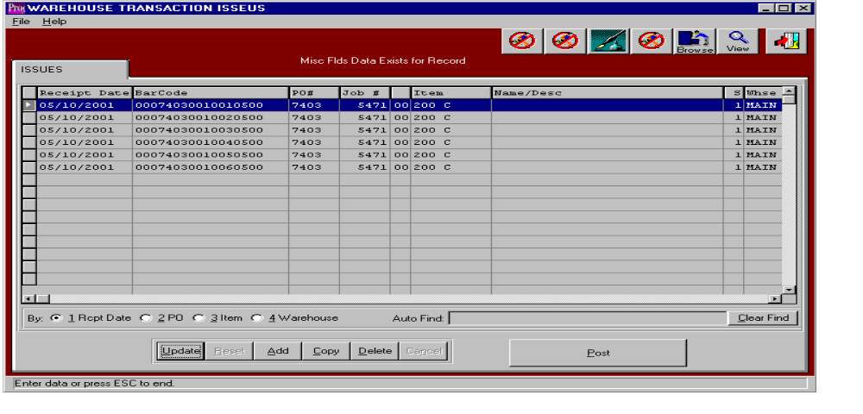

Raw Materials Scan Issues

Bar Coded Load Tags may be scanned as issues records by pressing the Scan Issues button. Each tag scanned will create a raw materials issues line and the job number will transfer from the item’s bin location. For stock sheets and rolls, the job number must be manually entered or scanned from the job ticket. Purchase orders for specific jobs may automatically create the materials issues when the raw material receipt is created by creating bar coded load tags. To simultaneously issue tags upon receips, the system administration auto issue flag is used. For more accurate and timely inventory control, pallet and roll tag issues should be manually added directly to the Advantzware issues file by scanning the bar coded tag number via the Scan Issues Button. Lastly, issues may be manually added to this file by searching for the item and tag numbers. Once the issues for each tag number are created, the list of issues are shown in this file for updating, deletion and posting. Issues may be posted one at a time or in a batch via the POST button. The list of issues may be sorted by receipt date, purchase order number, item number and warehouse by clicking the appropriate circle at the bottom of the screen. To search alphabetically, click the appropriate sort option, enter in a continuous string of characters in the Auto Find box, then press Enter.

To manually add material issues, press the Add button at the bottom of the screen. Select any item by pressing F1 on the item code, then enter the remaining data and press the enter key or click the Save button to save the transaction. The F1 key may be used to find an appropriate purchase order number, job number, warehouse, and bin location or unit of measure. To update a material issue, simply double click the item or press the Update button at the bottom of the screen. Press the Enter key or click the save button to save the transaction. The F1 key may be used to find an appropriate purchase order number, job number, warehouse, and bin location or unit of measure. To copy a material issue, highlight the item with a single click, then press the Copy button at the bottom of the screen. Press the Enter key or click the save button to save the transaction. The F1 key may be used to find an appropriate purchase order number, job number, warehouse, and bin location or unit of measure. To delete a material issue, highlight the item with a single click, then press the Delete button at the bottom of the screen. Press the Enter key or click the save button to save the transaction. The F1 key may be used to find an appropriate purchase order number, job number, warehouse, and bin location or unit of measure. To Post a material issue, highlight each item with a single click, then press the POST button at the bottom of the screen. Alternatively, the POST button on the main menu may be used to post the entire batch of receipts, issues, transfers, adjustments and physical counts.
ADVANCED SOFTWARE SERVICES, INC
RM - SCAN TRANSFERS
ADVANCED SOFTWARE SERVICES, INC
RM - ENTER / MODIFY TRANSFERS
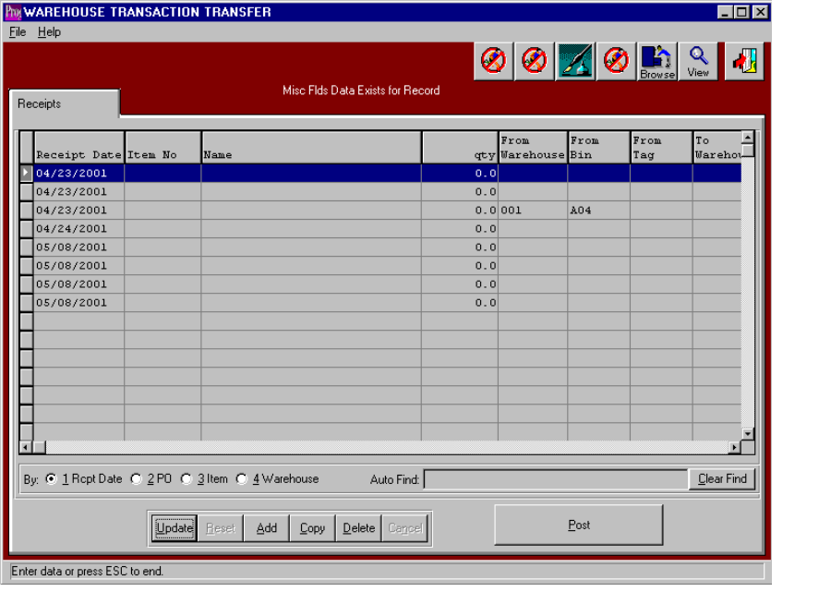

Raw Materials Enter / Modify Transfers

Raw materials transfers may be created directly to this file by scanning the bar coded tag number by utilizing the Scan Issues Button. Alternatively, transfers may be manually added to this file by searching for the item and tag numbers. Once transfers for each tag number are created, the list of transfer records are displayed for updating, deletion and posting. Transfers may be posted one at a time or in a batch via the POST button. The list of transfers may be sorted by receipt date, purchase order number, item number and warehouse by clicking the appropriate circle at the bottom of the screen. To search alphabetically for a transfer record, click the appropriate sort option, enter in a continuous string of characters in the Auto Find box, then press Enter.

To manually add material transfers, press the Add button at the bottom of the screen. Select any item by pressing F1 on the item code, then enter the remaining data and press the enter key or click the Save button to save the transaction. The F1 key may be used to find an appropriate purchase order number, job number, warehouse, and bin location or unit of measure. To update a material transfer, simply double click the item or press the Update button at the bottom of the screen. Press the Enter key or click the save button to save the transaction. The F1 key may be used to find an appropriate purchase order number, job number, warehouse, and bin location or unit of measure.

To copy a material transfer, highlight the item with a single click, then press the Copy button at the bottom of the screen. Press the Enter key or click the save button to save the transaction. The F1 key may be used to find an appropriate purchase order number, job number, warehouse, and bin location or unit of measure. To delete a material transfer, highlight the item with a single click, then press the Delete button at the bottom of the screen. Press the Enter key or click the save button to save the transaction. The F1 key may be used to find an appropriate purchase order number, job number, warehouse, and bin location or unit of measure.

To Post a material transfer, highlight each item with a single click, then press the POST button at the bottom of the screen. Alternatively, the POST button on the main menu may be used to post the entire batch of receipts, issues, transfers, adjustments and physical counts.

ADVANCED SOFTWARE SERVICES, INC
RM - SCAN ADJUSTMENTS

ADVANCED SOFTWARE SERVICES, INC
RM - ENTER / MODIFY ADJUSTMENTS

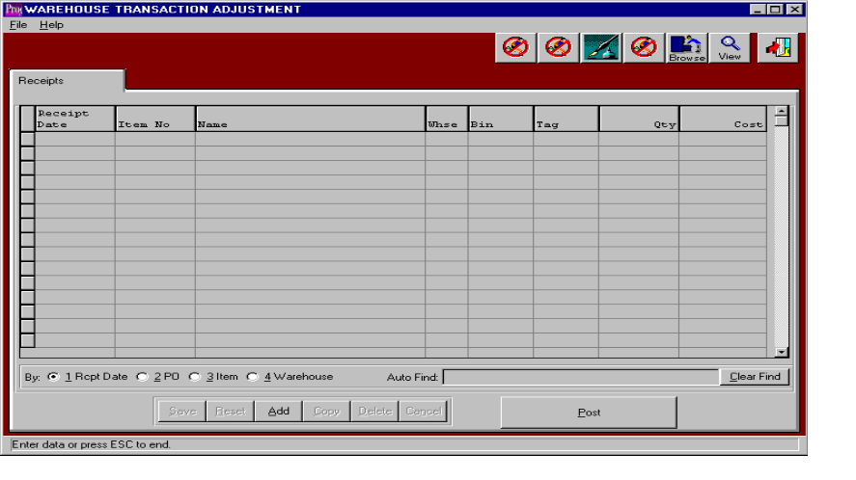

Raw Materials Enter / Modify Adjustments

Raw materials adjustments may be created directly to this file by scanning the bar coded tag number by utilizing the Scan Adjustments Button. Alternatively, adjustments may be manually added to this file by searching for the item and tag numbers, then entering the increase or decrease in quantity or cost. Once adjustments for each tag number are created, a list of adjustment records are shown for further updating, deletion and posting. Issues may be posted one at a time or in a batch via the POST button. The list of adjustments may be sorted by receipt date, purchase order number, item number and warehouse by clicking the appropriate circle at the bottom of the screen. To search alphabetically for an adjustment record, click the appropriate sort option, enter in a continuous string of characters in the Auto Find box, then press Enter.

To manually add material adjustments, press the Add button at the bottom of the screen. Select any item by pressing F1 on the item code, then enter the remaining data and press the enter key or click the Save button to save the transaction. The F1 key may be used to find an appropriate purchase order number, job number, warehouse, and bin location or unit of measure. To update a material adjustment, simply double click the item or press the Update button at the bottom of the screen. Press the Enter key or click the save button to save the transaction. The F1 key may be used to find an appropriate purchase order number, job number, warehouse, and bin location or unit of measure.

To copy a material adjustment, highlight the item with a single click, then press the Copy button at the bottom of the screen. Press the Enter key or click the save button to save the transaction. The F1 key may be used to find an appropriate purchase order number, job number, warehouse, and bin location or unit of measure. To delete a material adjustment, highlight the item with a single click, then press the Delete button at the bottom of the screen. Press the Enter key or click the save button to save the transaction. The F1 key may be used to find an appropriate purchase order number, job number, warehouse, and bin location or unit of measure.

To Post a material adjustment, highlight each item with a single click, then press the POST button at the bottom of the screen. Alternatively, the POST button on the main menu may be used to post the entire batch of receipts, issues, transfers, adjustments and physical counts.
ADVANCED SOFTWARE SERVICES, INC
RM - PHYSICAL COUNT PROCESSING
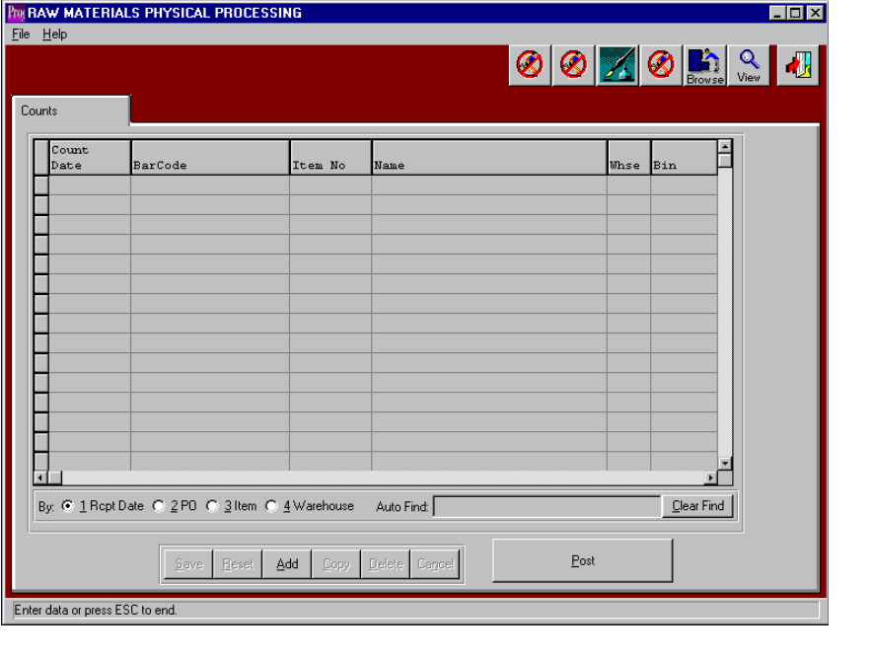

Raw Materials Physical Counts

Raw materials physical counts may be transferred to this file from the Top Gun batch data collection scanning device by pressing the IMPORT Physical Count Button or physical counts may be scanned directly from the plant floor by pressing the SCAN PHYSICAL COUNTS Button. Lastly, physical counts may be manually added to this file by searching for the item and tag number, then entering the correct quantity. Once physical counts for each tag number have been imported or created, a list of counted records are shown for further updating, deletion and posting. Physical counts may be posted one at a time or in a batch via the POST button. The list of items which were counted may be sorted by receipt date, purchase order number, item number and warehouse by clicking the appropriate circle at the bottom of the screen. To search alphabetically for an adjustment record, click the appropriate sort option, enter in a continuous string of characters in the Auto Find box, then press Enter.

To manually add physical counts, press the Add button at the bottom of the screen. Select any item by pressing F1 on the item code, then enter the remaining data and press the enter key or click the Save button to save the transaction. The F1 key may be used to find an appropriate purchase order number, job number, warehouse, and bin location or unit of measure. To update an items physical count, simply double click the item or press the Update button at the bottom of the screen. Press the Enter key or click the save button to save the transaction. The F1 key may be used to find an appropriate purchase order number, job number, warehouse, and bin location or unit of measure.

To copy a physical count record, highlight the item with a single click, then press the Copy button at the bottom of the screen. Press the Enter key or click the save button to save the transaction. The F1 key may be used to find an appropriate purchase order number, job number, warehouse, and bin location or unit of measure. To delete an items physical count, highlight the item with a single click, then press the Delete button at the bottom of the screen. Press the Enter key or click the save button to save the transaction. The F1 key may be used to find an appropriate purchase order number, job number, warehouse, and bin location or unit of measure.

To post a physical count record or batch, highlight each item with a single click, and then press the POST button at the bottom of the screen. Alternatively, the POST button on the main menu may be used to post the entire batch of receipts, issues, transfers, adjustments and physical counts.
ADVANCED SOFTWARE SERVICES, INC
RM - POST

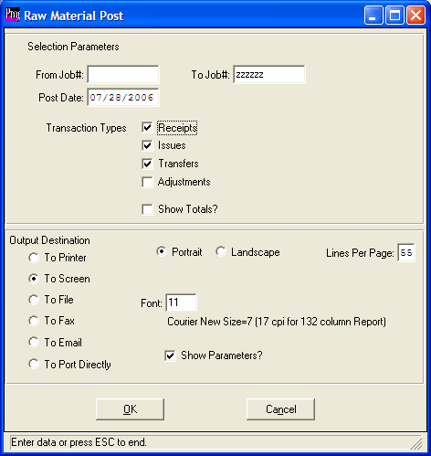

Raw Material Post

The post button on the main menu provides the ability to post warehouse transactions in a batch to a particular date. A job number range may be added to post a few select numbers of jobs. Like wise, transactions types may be selected to post any
number of transactions such as receipts, issues, transfers, adjustment and Physical counts.

ADVANCED SOFTWARE SERVICES, INC
FG – WAREHOUSE TRANSACTIONS MENU

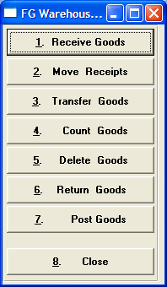

Finished Goods Warehouse Transaction Selections

Load tags may be created from purchasing, from jobs or directly from the Finished Goods file by pressing the appropriate button. When Finished Goods are received from purchasing, the receiving clerk will create load tags for the number of incoming pallets by pressing the load tag creation button. Each pallet tag created may simultaneously create Finished Goods receipts in the Advantzware Receipts file. Similarly, when Finished Goods are received from production, the receiving clerk will create load tags for the number of incoming pallets by pressing the Load Tag Creation Tag button. Each tag created will simultaneously create Finished Goods receipts. Once the load tags are created, they will be attached to each pallet. The load tag will show the purchase order number, item number, job number, unit count and a bar code load tag number. For purchased finished goods, the bar code is created by combining the purchase order number, the line number, the unit number and the unit count for each pallet received. For finished goods produced from jobs, the bar code is created by combining the finished goods item code and a sequential number. Alternatively, a vendor supplied load tag for purchased may be scanned, which will automatically create the warehouse receipt. Receipts for finished goods without bar coded tags may be added via the Enter/Modify Receipts button. The Post button will update the inventory levels in the Advantzware database.

The Scan Bill of Lading button is used to scan finished goods tag number onto the bill of lading, which will import the item number, tag number, job number and unit count to the Enter/Modify Bill of Lading file. The Advantzware system will be used to print the bill of lading and post the bill of lading.

The Scan Transfers button is used to transfer Finished Good tags to another warehouse and bin location. Once the item’s tag number is scanned, the new warehouse and bin locations is scanned, then the transaction should be posted to update the inventory.

For physical counting, the warehouse clerk simply scans the pallet tag and verifies or adjusts the pallet count. Once the data has been collected, the information must be posted to the Advantzware database. The posting button logic will be used to update the inventory files.

ADVANCED SOFTWARE SERVICES, INC
FINISHED GOODS – LOAD TAG CREATION

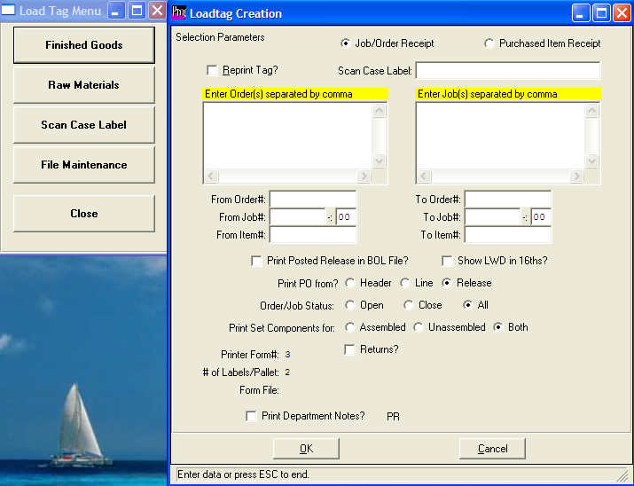

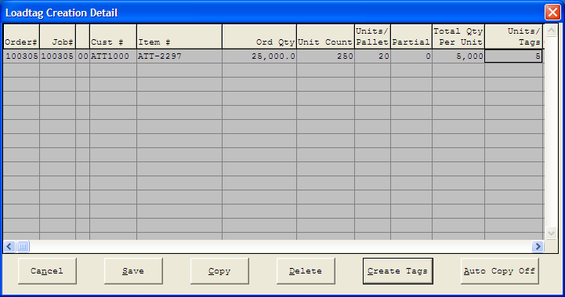

Finished Goods Load Tag CREATION

Load tags may be created for purchased finished goods upon receipt, from production finishing or in the office.
Load tags for Inventory that is stocked in corrugated cases may created by scanning the bar code on the case label. Alternatively, the job number may be scanned for a job card or the use may enter the order number, job number or item code. Once entered, the program generates a worksheet so that the receiving clerk will type the number of tags, quantity per pallet, quantiy per case or bundle, untis per pallet and any partial unit quantity. Once the CREATE AGS button is pressed, the load tags are create, printed and may simultaneously create Finished Goods receipts in the Advantzware Receipts file is the N-K-1 FGReceipt parameter is set to LOADTAG. The number of load tags per pallet may be defined for each customer or a default number per pallet may be set in the N-K-1 LOADTAG parameter. Once the load tags are printed, they will be attached to each pallet. The load tag will show the purchase order number, item number, job number, unit count and a bar code load tag number, which is created by combining the item code with a sequential number.

ADVANCED SOFTWARE SERVICES, INC
FG – ENTER / MODIFY RECEIPTS
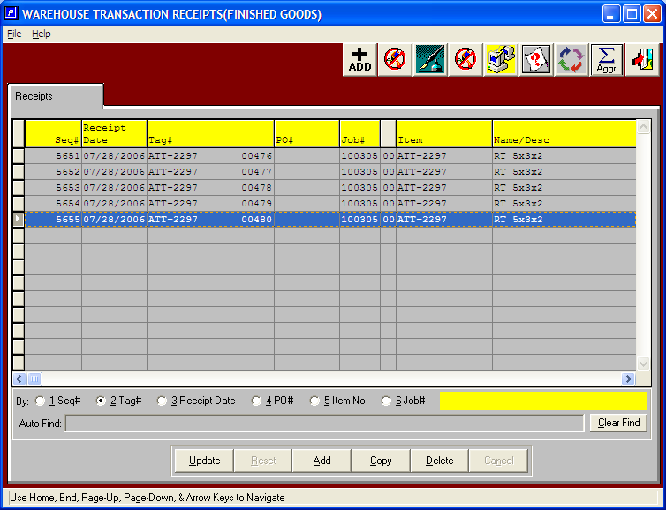

Finished Goods Enter / Modify Receipts

Load Tags created from purchase orders, jobs or from inventory button will create receipts transactions in the warehouse receipts file. Each load tag created will simultaneously create Finished Goods receipts in the Enter/Edit Receipts file. In addition, receipts may be added directly from this file without using a scanning device. When tags are created automatically the list of receipts are shown in this file for updating, deletion and posting. Receipts may be posted one at a time or in a batch via the POST button. The list of receipts may be sorted by receipt date, purchase order number, item number and warehouse by clicking the appropriate circle at the bottom of the screen. To search alphabetically, click the appropriate sort option, enter in a continuous string of characters in the Auto Find box, then press Enter.

To manually add finished goods receipts, press the Add button at the bottom of the screen. Select any item by pressing F1 on the item code, then enter the remaining data and press the enter key or click the Save button to save the transaction. The F1 key may be used to find an appropriate purchase order number, job number, warehouse, and bin location or unit of measure.

To update a Finished Goods receipt, simply double click the item or press the Update button at the bottom of the screen. Press the Enter key or click the save button to save the transaction. The F1 key may be used to find an appropriate purchase order number, job number, warehouse, and bin location or unit of measure.

To copy a Finished Goods receipt, highlight the item with a single click, then press the Copy button at the bottom of the screen. Press the Enter key or click the save button to save the transaction. The F1 key may be used to find an appropriate purchase order number, job number, warehouse, and bin location or unit of measure.

To delete a Finished Goods receipt, highlight the item with a single click, then press the Delete button at the bottom of the screen. Press the Enter key or click the save button to save the transaction. The F1 key may be used to find an appropriate purchase order number, job number, warehouse, and bin location or unit of measure.

To Post a Finished Goods receipt, highlight each item with a single click, then press the POST button at the bottom of the screen. Alternatively, the POST button on the main menu may be used to post the entire batch of receipts, issues, transfers, adjustments and physical counts.
ADVANCED SOFTWARE SERVICES, INC
FINISHED GOODS – SCANNING BILL OF LADING

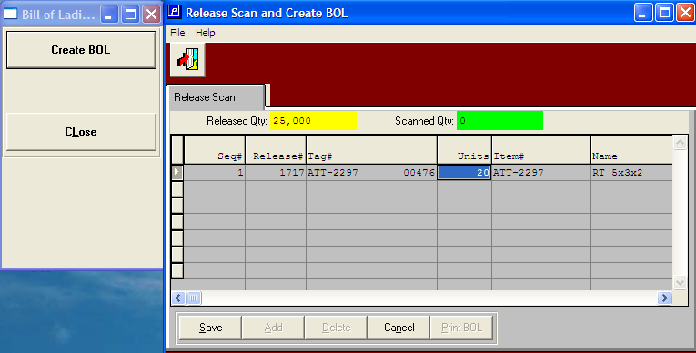

CREATE Bill of LadinG / SCAN TAGS

Bar Coded Load Tags may be scanned as shipment records on a bill of lading by pressing the Scan Bill of Lading Button. Once the user selects the bill of lading number, each tag number scanned will update the bill of lading lines file. The job number, item number, order number, warehouse, bin location and count will transfer directly to the bill of lading from the tag number. Once the bill of lading is completed, the bill of lading should be printed and then posted.
ADVANCED SOFTWARE SERVICES, INC
FG – ENTER / MODIFY BILL OF LADING

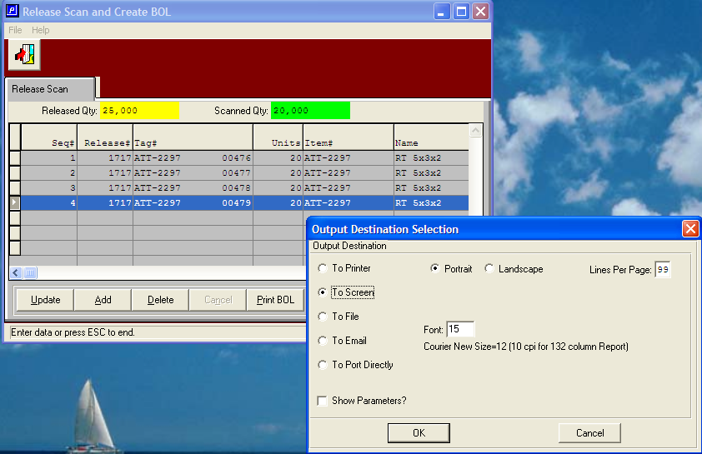

PRINT Bill of Lading

Finished Goods tag numbers may be scanned directly from Finished Goods onto the bill of lading file. Once the tag numbers have been transferred, the list of bills of lading and tag numbers are shown in this file for updating, deletion and posting. Issues may be posted one at a time or in a batch via the POST button. The list of issues may be sorted by receipt date, purchase order number, item number and warehouse by clicking the appropriate circle at the bottom of the screen. To search alphabetically, click the appropriate sort option, enter in a continuous string of characters in the Auto Find box, then press Enter.

To manually add Finished Goods Tag numbers, press the Add button at the bottom of the screen. Select any item by pressing F1 on the item code, then enter the remaining data and press the enter key or click the Save button to save the transaction. The F1 key may be used to find an appropriate order number, release number, job number, warehouse, bin location or tag number.

To update a Finished Goods item number, simply double click the item or press the Update button at the bottom of the screen. Press the Enter key or click the save button to save the transaction. The F1 key may be used to find an appropriate purchase order number, job number, warehouse, bin location or tag number.

To copy a Finished Goods item, highlight the item with a single click, then press the Copy button at the bottom of the screen. Press the Enter key or click the save button to save the transaction. The F1 key may be used to find an appropriate purchase order number, job number, warehouse, bin location or tag number.

To delete a Finished Goods item, highlight the item with a single click, then press the Delete button at the bottom of the screen. Press the Enter key or click the save button to save the transaction. The F1 key may be used to find an appropriate purchase order number, job number, warehouse, bin location or tag number.

To Post a bill of lading, highlight each item with a single click, then press the POST button at the bottom of the screen. Alternatively, the POST button on the main menu may be used to post the entire batch of receipts, issues, transfers, adjustments and physical counts.
ADVANCED SOFTWARE SERVICES, INC
FG – SCAN TRANSFERS

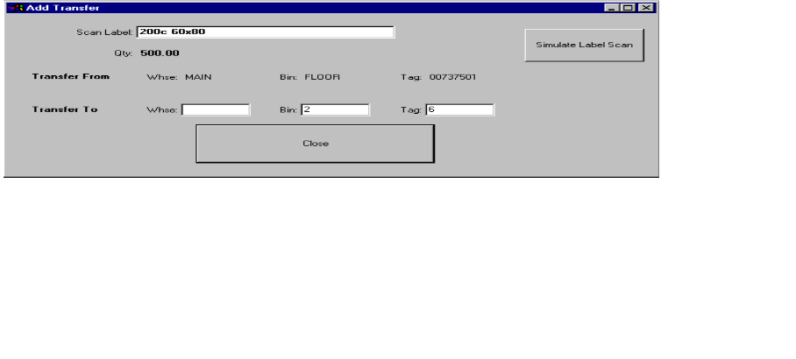

Finished Goods Scan Transfers

Bar Coded Load Tags located in the inventory file may be transferred to another warehouse and bin location by pressing the Scan Transfers button, then scanning the tag number, followed by scanning the new warehouse and bin bar code. Labels should be created which have a bar code for each warehouse and bin combination. Each label should be attached to the rack or hung from the isle for each warehouse and bin location. Each tag number scanned will create a Finished Goods transfer record in the Enter/Modify Transfers file, which must be posted after reviewing.
ADVANCED SOFTWARE SERVICES, INC
FG – ENTER / MODIFY TRANSFERS
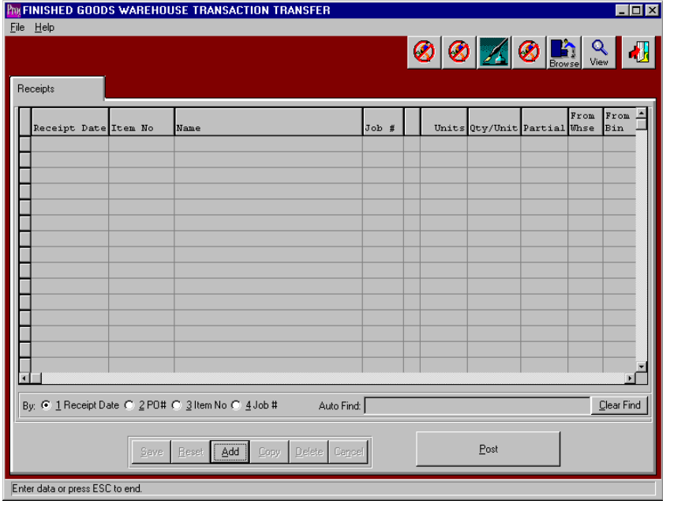

Finished Goods Enter / Modify Transfers

Finished Goods transfers may be created directly to this file by scanning the bar coded tag number by utilizing the Scan Issues Button. Alternatively, transfers may be manually added to this file by searching for the item and tag numbers. Once transfers for each tag number are created, the list of transfer records are displayed for updating, deletion and posting. Transfers may be posted one at a time or in a batch via the POST button. The list of transfers may be sorted by receipt date, purchase order number, item number and warehouse by clicking the appropriate circle at the bottom of the screen. To search alphabetically for a transfer record, click the appropriate sort option, enter in a continuous string of characters in the Auto Find box, then press Enter.

To manually add Finished Goods transfers, press the Add button at the bottom of the screen. Select any item by pressing F1 on the item code, then enter the remaining data and press the enter key or click the Save button to save the transaction. The F1 key may be used to find an appropriate purchase order number, job number, warehouse, and bin location or unit of measure.

To update a Finished Goods transfer, simply double click the item or press the Update button at the bottom of the screen. Press the Enter key or click the save button to save the transaction. The F1 key may be used to find an appropriate purchase order number, job number, warehouse, and bin location or unit of measure.

To copy a Finished Goods transfer, highlight the item with a single click, then press the Copy button at the bottom of the screen. Press the Enter key or click the save button to save the transaction. The F1 key may be used to find an appropriate purchase order number, job number, warehouse, and bin location or unit of measure.

To delete a Finished Goods transfer, highlight the item with a single click, then press the Delete button at the bottom of the screen. Press the Enter key or click the save button to save the transaction. The F1 key may be used to find an appropriate purchase order number, job number, warehouse, and bin location or unit of measure.

To Post a Finished Goods transfer, highlight each item with a single click, then press the POST button at the bottom of the screen. Alternatively, the POST button on the main menu may be used to post the entire batch of receipts, issues, transfers, adjustments and physical counts.

ADVANCED SOFTWARE SERVICES, INC
FG – SCAN ADJUSTMENTS
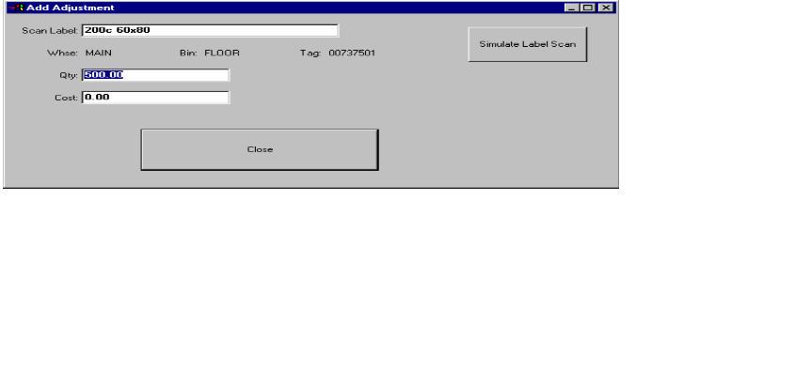

Finished Goods Scan Adjustments

Bar Coded Load Tags quantity and cost may be adjusted by pressing the Scan Issues button, then scanning the tag number, followed by entering the increase or decrease in quantity or cost. Each tag number scanned will create a Finished Goods adjustment record in the Enter/Modify Adjustments file, which must be posted after reviewing.

ADVANCED SOFTWARE SERVICES, INC
FG – ENTER / MODIFY ADJUSTMENTS
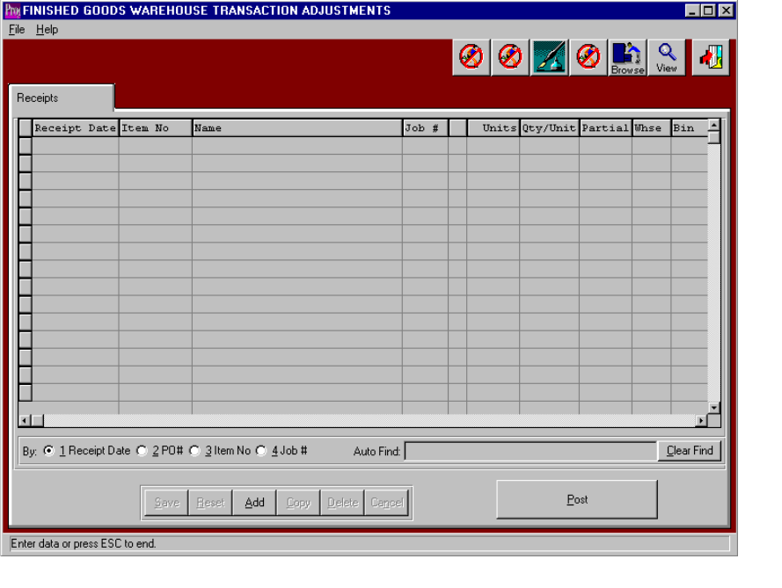

Finished Goods Enter / Modify Adjustments

Finished Goods adjustments may be created directly to this file by scanning the bar coded tag number by utilizing the Scan Adjustments Button. Alternatively, adjustments may be manually added to this file by searching for the item and tag numbers, then entering the increase or decrease in quantity or cost. Once adjustments for each tag number are created, a list of adjustment records are shown for further updating, deletion and posting. Issues may be posted one at a time or in a batch via the POST button. The list of adjustments may be sorted by receipt date, purchase order number, item number and warehouse by clicking the appropriate circle at the bottom of the screen. To search alphabetically for an adjustment record, click the appropriate sort option, enter in a continuous string of characters in the Auto Find box, then press Enter.

To manually add Finished Goods adjustments, press the Add button at the bottom of the screen. Select any item by pressing F1 on the item code, then enter the remaining data and press the enter key or click the Save button to save the transaction. The F1 key may be used to find an appropriate purchase order number, job number, warehouse, and bin location or unit of measure.

To update a Finished Goods adjustment, simply double click the item or press the Update button at the bottom of the screen. Press the Enter key or click the save button to save the transaction. The F1 key may be used to find an appropriate purchase order number, job number, warehouse, and bin location or unit of measure.

To copy a Finished Goods adjustment, highlight the item with a single click, then press the Copy button at the bottom of the screen. Press the Enter key or click the save button to save the transaction. The F1 key may be used to find an appropriate purchase order number, job number, warehouse, and bin location or unit of measure.

To delete a Finished Goods adjustment, highlight the item with a single click, then press the Delete button at the bottom of the screen. Press the Enter key or click the save button to save the transaction. The F1 key may be used to find an appropriate purchase order number, job number, warehouse, and bin location or unit of measure.

To Post a Finished Goods adjustment, highlight each item with a single click, then press the POST button at the bottom of the screen. Alternatively, the POST button on the main menu may be used to post the entire batch of receipts, issues, transfers, adjustments and physical counts.

ADVANCED SOFTWARE SERVICES, INC
FG – PHYSICAL COUNT
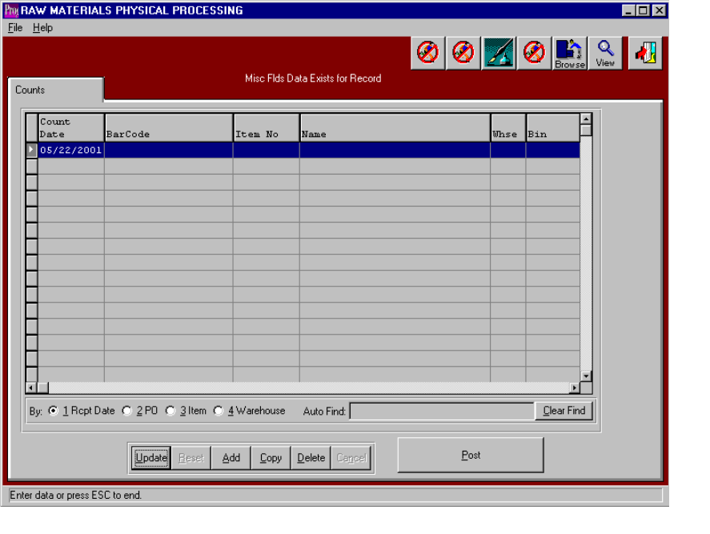

Finished Goods Physical Counts

Finished Goods physical counts may be transferred to this file from the Top Gun batch data collection scanning device by pressing the IMPORT Physical Count Button or physical counts may be scanned directly from the plant floor by pressing the SCAN PHYSICAL COUNTS Button. Lastly, physical counts may be manually added to this file by searching for the item and tag number, then entering the correct quantity. Once physical counts for each tag number have been imported or created, a list of counted records are shown for further updating, deletion and posting. Physical counts may be posted one at a time or in a batch via the POST button. The list of items which were counted may be sorted by receipt date, purchase order number, item number and warehouse by clicking the appropriate circle at the bottom of the screen. To search alphabetically for an adjustment record, click the appropriate sort option, enter in a continuous string of characters in the Auto Find box, then press Enter.

To manually add physical counts, press the Add button at the bottom of the screen. Select any item by pressing F1 on the item code, then enter the remaining data and press the enter key or click the Save button to save the transaction. The F1 key may be used to find an appropriate purchase order number, job number, warehouse, and bin location or unit of measure.

To update an items physical count, simply double click the item or press the Update button at the bottom of the screen. Press the Enter key or click the save button to save the transaction. The F1 key may be used to find an appropriate purchase order number, job number, warehouse, and bin location or unit of measure.

To copy a physical count record, highlight the item with a single click, then press the Copy button at the bottom of the screen. Press the Enter key or click the save button to save the transaction. The F1 key may be used to find an appropriate purchase order number, job number, warehouse, and bin location or unit of measure.

To delete an items physical count, highlight the item with a single click, then press the Delete button at the bottom of the screen. Press the Enter key or click the save button to save the transaction. The F1 key may be used to find an appropriate purchase order number, job number, warehouse, and bin location or unit of measure.

To Post a physical count record or batch, highlight each item with a single click, then press the POST button at the bottom of the screen. Alternatively, the POST button on the main menu may be used to post the entire batch of receipts, issues, transfers, adjustments and physic 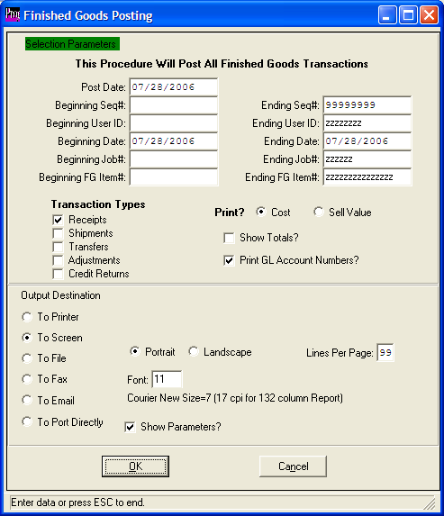al counts.

